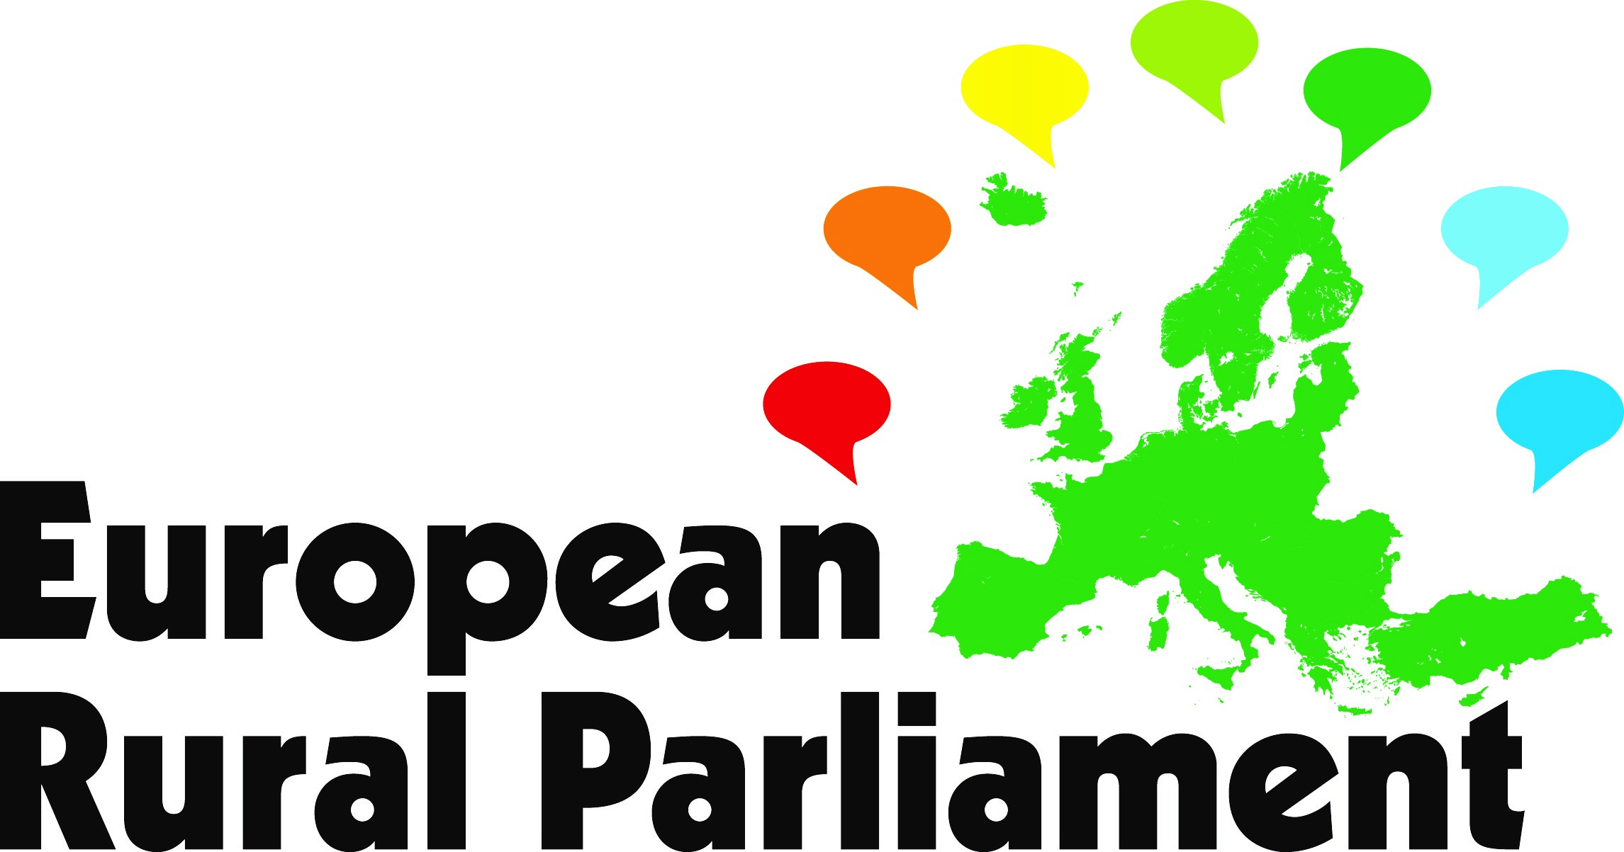

European Rural Manifesto
Final draft
1.We, representatives of many people and organisations rooted in rural Europe, have adopted this European Rural Manifesto as a statement of the aspirations, commitments and demands of rural people, drawing upon meetings in many countries during the European Rural Parliament campaign.
2.Diversity of rural areas. We deeply appreciate the wide diversity of rural peoples in Europe, arising from the varied geomorphology, climate and biodiversity of land and sea and from the long history of human activity across the continent. We see this variety, as expressed in human culture and natural resources, as an enormous opportunity for the future well-being of all peoples in Europe.
3.Common values. We acclaim the common values which bind the people of Europe – democracy, equality, the rule of law, recognition of human rights, the spirit of cooperation. We are impressed by the common themes emerging from the European Rural Parliament campaign across the face of Europe, from the Atlantic to the Black Sea and from Scandinavia to the Mediterranean.
4.Quality of life. Those who live in rural Europe value highly the quality of life which is offered by the countryside, the farms, villages and small towns, the coastal margins and islands, with their local cultures, wildlife, landscapes, healthy environment and cultural heritages.
5.Concern about rural conditions. However, in very many rural regions, residents are deeply concerned by the narrowness of rural economies, the lack of opportunities for satisfying and fairly-paid work, the loss of population as young people move away, the decline in rural services, the suffering of older people, poverty and social exclusion among disadvantaged people or ethnic minorities.
6.The need for action. We believe passionately that these challenges must be addressed, for the sake not only of the rural communities but also of the whole population of Europe. We all depend on food, timber, fibre, energy, water and minerals produced in rural areas. Farmers and rural enterprises create this common wealth. Rural areas contribute greatly to amelioration of climate, recreation, public health and social, economic and spiritual well-being.
7.Rights. We assert the right of rural areas and communities to full recognition by all the people and institutions of Europe, to a quality of life and standard of living equal to that of urban populations, and to full participation in political processes. We ask governments at all levels to endorse that right.
8.Vision. Our vision for the future of rural Europe is of vibrant, inclusive and sustainable rural communities, supported by diversified rural economies and by effective stewardship of high-quality environment and cultural heritage. We believe that rural communities, modelled on that vision, can be major long-term contributors to a prosperous, peaceful, just and equitable Europe, and to a sustainable global society.
9.Partnership. The pursuit of that vision demands in every country a refreshed and equitable partnership between people and governments. We, the rural people and organisations, know that we have a responsibility to give leadership and to act towards our own collective well-being. But we also fairly demand that governments at all levels, including the European institutions, work to make this crucial partnership effective.
10.Review of the state of rural areas. We urge the European Union, perhaps with help from one or more leading Foundations, to mount a major review of the condition of rural areas within the European Union, and of the contribution which rural areas now make, and can further make, to the well-being of the Union. The report on this review should be published in 2017, to mark the 30th anniversary of the report ‘The Future of Rural Society’. Its conclusions should be reflected in enhanced focus upon rural areas within all relevant EU programmes and funds.
11.Reversing the spiral of decline. Many regions are affected by a ‘downward spiral’ in the vitality of rural communities. Loss of population (particularly of young people) leads to reduced viability of rural services and weakened local economies, which prompts more loss of population. We call for concerted efforts by rural stakeholders, all relevant agencies and governments to ‘reverse the spiral’ by promoting pride in rural values, strengthening rural services, diversifying rural economies, and enabling young people to stay in or return to the rural areas.
12.Youth. Many young people are ready to stay in, or move into, rural areas and to take responsibility as farmers, rural entrepreneurs or citizens for the future well-being of rural economies and communities. They need attractive jobs, effective systems of education and vocational training, apprenticeships based on local needs, access to land, housing and credit, social and cultural activities suited to young people, and specific support to young farmers and entrepreneurs. We call on governments and civil society to meet these needs and to enable young people to participate actively in political processes.
13.Refugees. The arrival of desperate people from areas of conflict and disaster, seeking refuge and new lives in Europe, is provoking thought and action within our networks. We call for a warm-hearted response, based on solidarity between peoples. We believe that for many rural areas, and particularly those with declining populations, this offers an opportunity to integrate refugees and other new comers. The process of integration must include the necessary job creation, investment in housing, services and infrastructure. Successful integration efforts should be celebrated.
14.Poverty and exclusion. We recognise the progress that has been made in fighting poverty and social exclusion in Europe. But millions of people are still afflicted by poverty and social exclusion of different kinds. Social and territorial cohesion are integral to our vision of Europe. We call for sustained effort to promote inclusion and full participation in society. Of particular concern are the needs of Roma communities in many Central and Eastern European countries, who are among the poorest and most excluded of all Europe’s rural people. They should be recognised as people with equal rights to suitable jobs and education for their children. All people have talents and skills to offer.
15.LEADER and CLLD. We strongly advocate a territorial, integrated and partnership-based approach to rural development. We wish to see the widespread application of the LEADER principle, and its extension into Community Led Local Development, both within and beyond the EU. We urge institutions and governments within the EU to demonstrate trust in Local Action Groups, to expand their funding, and to extend the multi-funded approach opened up by CLLD. We urge all sectors in the Western Balkan and Black Sea countries to lay the groundwork of partnership between sectors for the use of LEADER and CLLD.
16.Rural Services and infrastructure. Basic rural services, such as shops, post offices, schools, primary health care and public transport as well as social infrastructure, are vital underpinning to the quality of life in rural areas. Adequate infrastructure – water supplies, sewerage systems, and electricity, gas or oil supplies, transport systems – is also vital. But in many rural regions, infrastructure is inadequate and rural services are already weak or being lost, which can start a vicious cycle of decline. We call upon governments and service providers to recognise the right of rural people to adequate infrastructure and reasonable access to all basic services, and to take action so that communities are enabled to make decisions appropriate for their needs.
17.Broadband communication. Access to high-capacity telecommunications is becoming crucial to the social, cultural and economic life of all Europeans and to the provision of vital services. Rural areas, particularly in central and Eastern Europe and many peripheral EU regions, are at present gravely disadvantaged by weakness in telecommunication systems. We call on governments, multi-national funders and telecommunication providers to work urgently towards access to high-speed broadband for all rural populations.
18.Local and sub-regional economies. The rural regions of Europe embrace thousands of local and sub-regional economies, rich in micro, small and medium-sized enterprises, which form the lifeblood of communities and contribute greatly to the broader economies of European nations. We assert the high importance of sustaining the vitality and viability of these local and sub-regional economies throughout rural Europe. The means of doing so will vary from place to place, but can embrace initiative in many different sectors – agriculture, forestry, energy production, added-value enterprises, tourism and service industries, plus businesses based on information technology. There is high scope for social enterprises. Of high importance is the provision of versatile advisory, business support and credit services, plus vocational education and training, accurately geared to the existing and potential job opportunities.
19.Small and family farms. We recognise the major contribution that commercial farms make to the European economy. However, we are gravely concerned with the loss of the farm labour force, and for the well-being of the many millions of small and family farms, within the EU and in South East Europe and the Black Sea Region, especially in remote areas, mountains and islands. These farms give livelihood to millions of families, provide food to local markets, form the staple population of thousands of communities, and sustain traditional ways of life on which the health of the land, landscapes, ecosystems and cultural heritage depend. They may retain viability by forming cooperatives, adding value collectively to their products, diversifying their local economies and gradually forming larger land units. We urge governments, donors, civil society organisations and rural communities to recognise and support family farming as a viable European model.
20.Small towns. Small towns, which number thousands in Europe, have crucial importance as social, economic and cultural centres for rural communities. They are the centres of commerce, public and social services, secondary schools and healthcare, and offer major opportunities for tourism.. However, they are not recognised as a major target of national or European policies and programmes, often being perceived as neither rural nor urban. We advocate a mainstream European Union policy focused on small towns, recognising all the important contributions they make in the social and economic structures of rural regions and their vitality; and for greater focus on the needs of small towns in national policies
21.Climate change and natural resources. In the run-up to the United Nations Conference on Climate Change, we assert the major role which the rural areas of Europe can play in combatting climate change and sustaining environmental resources; and also recognise the need to assist rural areas to adapt to climate change. Over 40 percent of the land surface of Europe is in forests, which can capture and sequestrate carbon and which contribute massively to renewable resources of raw material and energy. Rural areas are well placed to meet the growing demand for renewable energy from wind, hydro, solar, heat exchange and wood fuel sources, in ways which respect the environment and which bring direct benefit and employment to rural communities. We call for increased use of agro-forestry, agro-ecology and bio economy approaches.
22.Western Balkans and South East Europe. Rural communities and economies in the Western Balkans and South East Europe countries are deeply affected by the political instability in the region. The process of accession to the EU is on hold. This slows up the process of political reform. Rural development is seen as a low priority. We urge the EU to revitalise the accession process in this region, including much more effective support to rural development processes.
23.Leadership in rural development. We acknowledge the important role of leadership at all levels and between levels. We recognize that a prime responsibility for identifying needs and delivering solutions rests with us, the rural actors. However, leadership in rural development involves collective action from local, regional, national and European levels and is characterized by commitment, communication, cooperation and building trust. We call upon civil society, governments and the private sector to work in partnership to offer capacity building, resources and support to foster an environment which encourages innovative, sustainable and accountable leadership, inspiring and engaging future leaders.
24.Civil Society Networks. The European and national networks which have led this European Rural Parliament campaign are rooted in local action and participative democracy. Their membership includes thousands of village-level action groups, local associations, cooperatives and other structures which run essential services and promote cooperation among rural actors. We call upon governments and the European institutions to respect the independence of NGOs and their networks and to support their activities.
25.Partnership between civil society and governments. We believe that effective rural development demands an open-minded and innovative partnership between people and governments, side by side as equals. We call upon rural stakeholders to work positively with governments; and upon governments to establish meaningful systems of consultation and collaborative decision making, in order to enable rural stakeholders to participate in shaping policies and to lay a strong foundation for fruitful partnership between rural stakeholders and governments at all levels.
26.A supportive climate. We call on governments to act in a spirit of trustful and open-minded partnership with rural communities, and to provide a supportive climate of law, regulation, administration and finance. This supportive climate should include a full commitment to democracy and the rule of law; coherence between different aspects of policy across the whole field of government action related to rural areas; rural proofing of all relevant policies and programmes; and sensitive and flexible use of regulatory, fiscal and financial systems to encourage initiative by individuals, small and medium-sized enterprises, cooperatives and others; and respect for international laws and treaties.
27.International exchanges. We believe that the work to achieve sustainable rural development throughout the wider Europe can be greatly assisted and accelerated by exchange of good practices among rural stakeholders and governments in all European countries and further afield. East and West can equally contribute to, and gain from, such exchanges. We call for a truly pan-European approach to exchange programmes, through cooperation between governments, NGOs, multi-national donors and others within and beyond the EU. A leading contribution to this process can be made by the European Network for Rural Development and the National Rural Networks in all EU members states.
28.Advocacy and action. We ask the European NGO networks which co-initiated the Second European Rural Parliament to lead a programme of advocacy and action based on this Manifesto, working closely with their national members and all willing partners.
29.Our pledge. We pledge our own continued commitment to the pursuit of the vision and the actions outlined in this Manifesto. We believe that the rural communities, the governments and the multi-national institutions, working together, can achieve a renaissance of the rural regions of Europe. With that conviction, we declare that ALL Europe Shall Live !
European Rural Manifesto 261015

